Individual Teacher's Profile

Name : SAHILA KHATUN
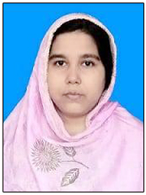
Designation : STATE ADDED COLLEGE TEACHER
Date of Birth : 01/03/1989
Citizenship : INDIAN
Gender : FEMALE
Marital Status : MARRIED
Official Address : Kaliachak College , Sultanganj , Malda 732201
Permanent Address : Vill- RANNUCHAK, POST- SHERSHAHI,
P.S- KALIACHAK , DIST- MALDA
PIN -732201
E-mail : sahilakhatun737@gmail.com
Mobile No : 7477684136
Academic Qualifications : M.A , B.Ed ,
Teaching Experience : Assistant lecturer in Education at Kaliachak
College from 01/12/2015 to till date

