Individual Teacher's Profile

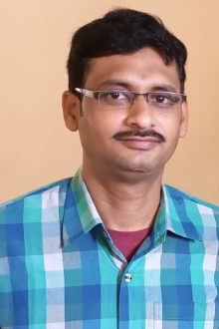

`
Name : : DR. ANUP KUMAR RAY
DEPARTEMANT : SANSKRIT
Designation: : State Aided College Teacher
Date of Birth : 02/02/1982
Citizenship : INDIAN
Gender : MALE
Marital Status : MARRIED
Official Address : Kaliachak College , Sultanganj, Malda 732201
Permanent Address : VILL- LAKSHMIJANARDANPUR, P.O- CHHATNA, P.S+ DIST-
BANKURA, PIN 722132
E-mail : anupkumarray13@gmail.com
Mobile No : 8436110802
Academic Qualifications : M.A , , Ph.D
Specialisation in : KAVYA
Teaching Experience 1.Part -time in Sanskrit at Kaliachak College from
20/08/2010 to 31/12/2019
2. State aided college teacher in sanskrit at
Kaliachak college from 01/01/2020 to till date

